State Regulation of Public Utilities Review Committee
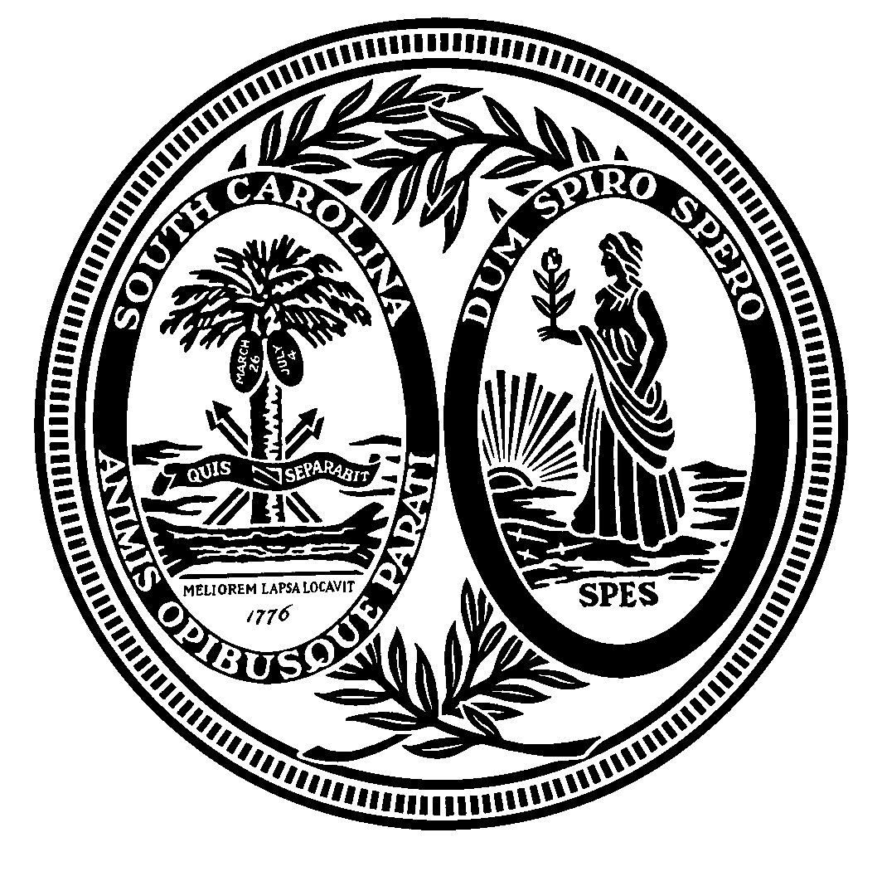
Sen. Thomas C. Alexander, Chairman Heather Anderson
Rep. William E. Sandifer, III, Vice Chairman Committee Counsel
Margaret Bluestein, Esquire Steve Davidson
Rep. P. Michael Forrester Committee Counsel
Sen. C. Bradley Hutto
Dan Jones
Rep. David J. Mack, III
Sen. Luke A. Rankin, Sr.
John S. Simmons, Esquire

Post Office Box 142
Columbia, South Carolina 29202
(803) 212-6208

LEGAL AD:

The State Regulation of Public Utilities Review Committee (“Review Committee”) is beginning its screening process for Seats 1, 3, 5, and 7 of the South Carolina Public Service Commission (“Commission”). The Review Committee will be accepting applications for Seats 1, 3, 5, and 7 beginning Monday, September 16, 2019, until 12:00 p.m., Friday, October 11, 2019. The Commission has jurisdiction over matters pertaining to investor-owned electric and gas utilities, water and wastewater companies, telecommunications companies, carriers of household goods and hazardous waste for disposal, taxicabs, and other motor vehicle passenger carriers. A commissioner must have at least a baccalaureate degree and should have a background of substantial duration in one of the following areas: (a) energy; (b) telecommunications; (c) consumer protection and advocacy; (d) water and wastewater; (e) finance, economics, and statistics; (f) accounting; (g) engineering; or (h) law.
The Commission is composed of seven commissioners, one from each of the seven Congressional districts. The Commissioner for the First Public Service Commission District represents Charleston, Berkeley, Beaufort, Dorchester, and Colleton counties. The Commissioner for the Third Public Service Commission District represents Oconee, Pickens, Anderson, Abbeville, Laurens, Greenwood, McCormick, Edgefield, and Saluda counties, as well as parts of Newberry, and Greenville counties. The Commissioner for the Fifth Public Service Commission District represents Cherokee, York, Union, Chester, Lancaster, Fairfield, Kershaw, and Lee counties, and parts of Spartanburg, Newberry, and Sumter counties. The Commissioner for the Seventh Public Service Commission District represents Chesterfield, Marlboro, Darlington, Dillon, Florence, Marion, Horry, and Georgetown counties. Salary for these positions is $129,482 annually.

Each candidate is required to submit a completed application form no later than the October 11th deadline. Applications will not be accepted after noon on Friday, October 11, 2019. Following the October 11th filing deadline, the Review Committee will begin its background investigation of candidates. Candidates and potential candidates are subject to certain restrictions with respect to contacting members of the General Assembly.
Application forms may be obtained from the State Regulation of Public Utilities Review Committee, 102 Gressette Building, Post Office Box 142, Columbia, South Carolina 29202, by contacting Heather Anderson, (803) 212-6208 or heatheranderson@scsenate.gov, or by contacting Michelle McGee, (803) 212-6634 or michellemcgee@scsenate.gov. For further information, contact Ms. Anderson or Ms. McGee, or the Review Committee’s website at: www.scstatehouse.gov/CommitteeInfo/PublicUtilitiesReviewComm/2019PublicServiceCommissionScreeningInfo.php.

